Elders Kerr & Co Annual Spring Cattle Sale
The Elders Kerr & Co Annual Spring sale was an absolute cracker as prices exceeded expectations with a lot of weight in the yarding showing the effects of the very good season which equated to big dollars per head. AuctionsPlus played a huge role in today’s sale results as 9 very active bidders were consistent as they placed over 270 bids. There were just short of 1400 catalogue views before sale today and over 200 online viewers.
There was a large offering of 820 Grown Steers as the bulk made from 415-427c/kg with a pen of Vinebanks Pastoral Company’s Hereford steers topping the portion at 465c/kg. AJ & AK Boyd (Greenhills) had a fantastic run of Murray grey cattle cattle on offer today as they averaged 440c/kg or $2114.07 per head! A smaller yarding of 273 Grown Heifers did not change the price results as a pen of Angus heifers made to a top of 432c/kg or $2077.60 with the bulk of the portion making from 400c/kg-417c/kg. Weighed Weaner Heifers soared today as cattle made to a top of 509c/kg or $1737.36 per head with the balance of the yarding making an average of 473.1c/kg.
There was an exceptional offering of Weighed Weaner Steers as a pen of 41 Angus Steers from Tathra Pastoral Partnership made to a top of 564c/kg. Pardoo Cattle Company also presented a large offering of well conditioned Angus Weaner steers with the most of their portion making 494c/kg or to a top price of $1925.18 per head!
Stony Point Partnership had 112 PTIC Females on offer today as the top pen made $2300 and the balance of the portion making an average of $2016.43!

Category | Tops
Grown Steers | Top $/h  Top c/kg | $2246.75  465.0
Grown Heifers | Top $/h  Top c/kg | $2077.60  432.0
Weaner Steers | Top $/h  Top c/kg | $2196.77  564.0
Weaner Heifers | Top $/h  Top c/kg | $1737.36  509.0
PTIC Females | Top $/h | $2300.00

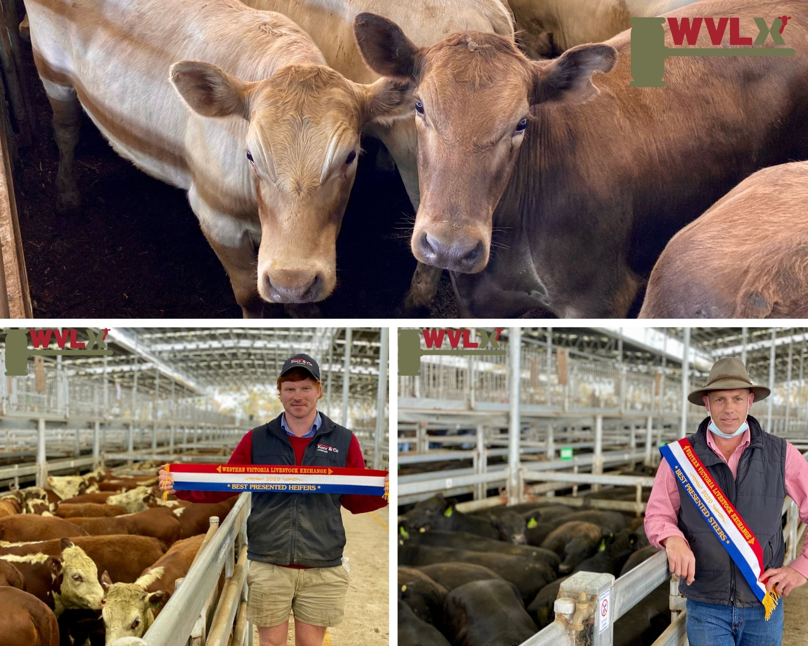
Top:
AJ & AK Boyd (Greenhills) had a fantastic run of Murray grey cattle cattle on offer today as they averaged 440c/kg or $2114.07 per head!
Bottom Right:
Coolana Rural PTY LTD were awarded the “Best Presented Pen Of Steers”. The 74 Angus steers went under the hammer for 470c/kg or to a top of $2176.36 per head!
Bottom Left:
Koolomurt Pastoral were awarded the “Best Presented Pen Of Heifers”. The well bred Hereford Heifers made to 420c/kg or $1859.16!

